Epitaph for a Planetary Biosphere…?

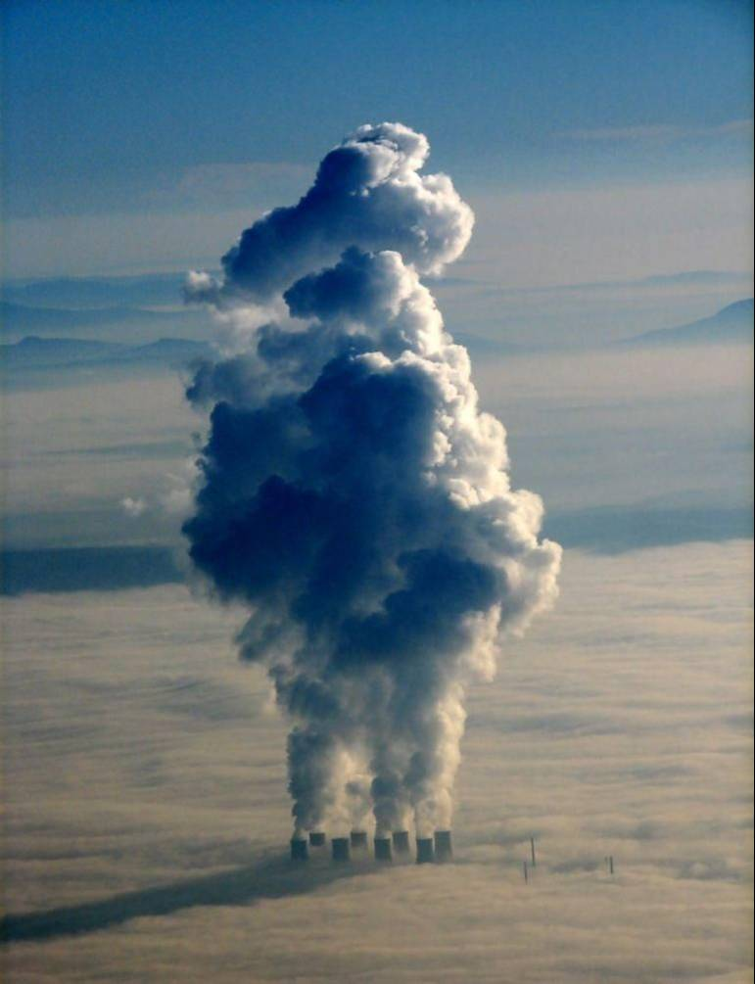

Notes on human population growth, mineral resources, climate change, and, the approaching Energy Cliff, or, looming interaction of the pending ‘cheap’ oil crisis, and metals deficits, unsustainable human economies, alternative crude energy creation and use, out-of-control human population numbers, and anthropogenic climate change. The Club of Rome (1972), is increasingly being vindicated..? (With particular reference to NZ.)

Metals are important to humans because they ultimately provide the optimum tools to maintain and advance culture and a secure way of life, now increasingly technologically oriented. Metallurgy was the great step forward in human cultural and intellectual development, involving tools of durable materials continually developing in form and application. The more and better the tools, the more and better the ideas generated by, and for, their ongoing use.

However, the consequent environmental and resource exploitation, as a result of that tool overuse that also gives us physical security and our present way of life in a modern first world society, (with so many others aspiring for the same status), has now reached certain easily-identifiable limits. Thus, human tool use must be modified to contrive a more sustainable way of life, and, a necessary reduction in sheer weight of human numbers is overdue. From the beginning of advanced tool use there have been warning signs, major and minor, regarding subsequent natural resource exploitation, and, of late, increasing Climate Change. But, these warnings have not always been heeded, especially when seen merely as challenges to be overcome by “re-tooling”; then it has been, and still is, ‘business as usual’.

Diverse environments must be maintained for healthy ecological systems, but our advanced tool use has given humans a false sense of security, re sustainable lifestyles, and also sustained a major human blind spot in regard to the health of the natural, non-human environment. Thus, unrealistic views of human resource management, and willful non-recognition of planetary biosphere injury, are now regrettably extant and obvious. Anthropogenic climate change now potentiates these changes, as well as generating unique biosphere disruption. Humans so easily betray their atavistic origins when they continually run their affairs on the basis of mob psychology, mindless breeding, and, companion feeding..? Human’s greatest blind spot is themselves..?

One serious sign of resource exploitation, for humans, is now imminent diminution of fossil oil availability, as predicted by M K Hubbert in 1956. (The natural world, however, may well be ‘relieved’ that this is eventuating..?) Oil is so necessary for intensive energy exploitation, for grid electricity, for transport, for aviation, etc., however advanced or basic these human systems are. Even if not equally distributed or always sensibly used, oil is a major support of our present world population. A major part of human tool use has always been development of energy resources and energy utilization, especially for intensive and on-demand use.

Firstly, there was energy from trees felled by stone and metal axes, then burnt, or turned into coke, followed by the discovery and wide scale use of coal, this especially being the foundation of the Industrial Revolution, along with advanced use of metallurgy. Later, in rapidly industrializing societies, ‘cheap’ energy has been further epitomized by the use of oil and its by-products, plus the ease of its bulk storage and transport and, everyday portability and use. Advanced tools development and use has been further accelerated by this easily available energy, as well as enabling its use. Hydroelectric power, where available, also powers forges as well as power grids, but, these dams must, in turn, be built by advanced tools, and for their manufacture, intensive energy use from a prior source is required, and this is usually derived from oil, or, high quality coking coal. Dams themselves exact a major environmental toll, as well, whether intended for hydro power, irrigation, or, just potable water.

Indeed, the metal supply, for whatever use, is also directly linked to energy supply because intensive energy use is required to locate, mine, process, and then manufacture metals, to realize their final usable tool forms. No proper regard for recycling also means that some trace elements are becoming harder to find and extract, not least those that are required for our new technological revolution, which now includes alternative energy systems such as solar power, as well as the balance of system components for all modern electricity reticulation. Mineral extraction is, directly or indirectly at every stage, energy intensive, and, environmentally costly.

There is no validity to claims that mining in remote areas, or in ‘wastelands’, is of little or no environmental consequence, and, to compound the problem further, improper and/or extravagant use of mined resources has meant that many extraction and processing costs to the environment have been further needless. Mixed planetary ecologies are essential for the perpetuation of all forms of life, but now, as our shared biosphere deteriorates, the 6th Major Extinction Agent is Us..! This fact is made more ironic by the fact that primates, including humans, are themselves the evolutionary products of a stable and rich ecosystem.

The Approaching Cliff refers to how abrupt and even catastrophic the changes will be, for the entire human world, when available fuel oil runs dry and/or becomes too expensive to extract and refine. The principle driving force of globalization is that of increasing reliance on trade that requires shipping, air, and rail, as well as the mass-transport of people that is so important, especially for tourism, in any participating economy. Maintaining livable environments in extreme climates, or seasonal extreme, is also important, and intensive and/or extensive agriculture also needs on-demand energy for production as well as processing. If the expected oil crisis strikes within a generation, there will be a human population that will be in excess of 9 billion by 2050, and, humanity seems little prepared to face the consequences of serious intensive energy non-availability.

Sensibly-applied advanced tool use is now urgently needed to develop alternatives while there is time, and that includes social and medical tools, and cultural education, to reduce human population numbers. (Of course, by default, Bird Flu, or similar, may help in this regard, not least because of our crowded societies, including with domestic animals, and, our ongoing abuse of antibiotic medical tools. This is the default human population reduction option that governments are well aware of, though choose not to publicly contemplate.)
The burning of 200 million years of accumulated fossil oil in just 200 years, including both coal and oil, has also bought its own brand of adverse environmental consequences, such as an increase of Greenhouse Gas Emissions, loss of forests, melted freshwater ice reserves, climate disruption, vegetation shifts, etc., and now, reduction in ease of this oil supply also figures in this continuing extravagance. Coal, still plentiful, would still replace oil as an intensive energy source for humans, but would not be clean-burning, as it would be impossible to police total extraction and burning of coal, whatever grade it was, and a ‘healthy’ black market would soon eventuate. Timber would be increasingly exploited as fuel, again with a black market, and this at a time when reforestation is so urgently needed, especially for locking up carbon. Many other ‘burnables’ would likewise add to rampant atmospheric pollution and carbon emissions, and bio-mass byproducts will add more GGEs, however cleanly burned.

Thus, no major human population reduction in the very near future will mean a catastrophic increase in aerosols of the worst kind, black carbon and sulphur, as well as attendant GGEs, while so many humans meet large energy needs, and, if/when methane clathrate deposits are irreversibly disturbed, a Runaway Greenhouse definitely looms unless this human ‘population v. energy use’ problem is quickly resolved. Permafrost melting is now a major source of CO2 and CH4. 25% of Eurasia is permafrost, with ever-accelerating melting. Sea level rise will further exacerbate land-based resources problems, including living space for all land-based life, not just humans. In business terms, human society, plus the entire planetary biosphere, are increasingly vulnerable to catastrophic failure on too many ‘fronts’. Breeding for-an increasing ‘market’ and ‘business as usual’, whilst ignoring sustainability and biosphere health, must end.

NZ is likely to be one of the least drastically-affected countries as a result of increasing climate change, although NZ society would soon feel the effects of increasing oil deficit by slowing of trade, especially as traded agricultural produce helps to pay for the fact that NZ has no major mineral deposits, no major smelting and manufacturing, thus, only possessing a rudimentary tertiary industry based mostly on assembly and parts replacement. NZ may be almost electricity independent, by virtue of hydro, plus some coal-generated power from local deposits, and with some emerging alternative energy. But, fuel oil is needed for transport, including for trade, local and regional automotive and rail, and alternative energy development may actually suffer as vital mineral resources and manufacturing go to the highest bidder, in another hemisphere or continent, because of NZ’s increasing global isolation due to rising transport costs, and/or slow times for real sailing ships..! (Domestic reversion to horses and carts will bring yet another string of resource problems, such as extra cropping, and another brand of urban pollution!)

An increasingly mixed energy economy is urgently required, from whatever natural resource, and, second to hydro power must be solar power, as an unlimited power source whose mass daily use will help to keep water behind dam walls. NZ is blessed with good solar resources for all seasons, especially due to our latitudinal spread. Wind and natural water power are not always consistent, are very expensive to install and maintain, and, both have greater natural hazard vulnerability than solar power generation, by virtue of their necessary physical locations. Geo-thermal power is similarly expensive, has an unknown lifetime anywhere, and, has considerable natural hazards to contend with, also by nature of location. Iceland a case-in-point..?

NZ will feed itself, climate and soils would still enable this, and is are not short of natural fibers and timber, but eventually, a population cap would be needed, not least because NZ would be seen as a food-basket by those other countries losing agricultural potential due to lack of intensive energy, or, because of increasing global warming consequences from collective energy misuse. These ‘food refugees’ will eventually include numbers from the neighbouring mini-continent, present population 21+ million, whose citizens are increasingly fated to be confined to coastal strips for living as global warming increases, presently needing energy- intensive transport links, as well as heavy reliance on refrigeration capabilities for foodstuff storage and transport to maintain their current population spread. Standby for Boat People off the western shores, or, any shores..?

The effect on individuals of all the preceding facts will vary, of course, anywhere in the world, and will be all-too-dependent on present socioeconomic status, climate, soils, water, and sustainable regional population numbers. For the author of this small commentary, having already had many previous Golden Years of education, travel, cheap energy, the proximity of smaller populations, plus, having also benefited from general world lack of urgency in the matters hitherto discussed, I personally may be affected in future matters of personal transport, less flexible health resources, a plainer diet, and, fewer personal luxury items that will follow on from the pending global energy crisis.

But really, it will be something of an adventure at this stage of my own life, and, there will be increasing political and social upheavals, technological changes, and strings of mishaps and disasters, all reported as long as there are newspapers, Internet and other mass media functioning to report them. An interesting phenomenon, with interesting consequences, especially if unchecked..? Very likely, personal survival into increasing old age may seem something of an extravagance, too, as a new ‘value’ of human life will replace the present well-meaning and misguided efforts in these matters. But, I will face that prospect as and when it comes….

Meanwhile, as a veteran of decades of heated discussions about global warming, a grandstand seat will at least now be mine to view major shifts in resource management, attempting of economic sustainability, alternate energy development, population control and then major reduction, and, with luck, a unique successful world co-operation that will promote a whole new vision of globalization, rather that just attempting world ‘progress’ merely to evolve an enormous consuming and (mostly) middle class of 11 billion people, (projected ultimate level of world demographic transition, and, optimistic at best?), always fated to fail most miserably and abjectly. Living like the Amish may only support 1/6 of present human numbers within our much-beleaguered biosphere, and about ¼ if everyone lived at the standard of the average Third World university undergraduate whose society is sustained by basic renewable energy resources..?

Forget carbon credits and geo-sequestration, etc., they are not only self-defeating, they are only a poor excuse for continuing human ‘business as usual’, once again an indication of how ‘re-tooling’ can convey a totally false sense of human destiny. (With luck, fusion power will never eventuate as part of human destiny..?) Human societies, cultures, economies, and education systems, must now change to cope with the healing of our shared biosphere. The Third World also just has to understand that aspiring to First World living standards, without a major demographic transition, is neither possible, nor sustainable. The Club of Rome will surely be proved right in the end, regarding human population numbers, and now, with the added impetus to catastrophe engendered by accelerating climate change. An intelligent organism that breeds prolifically, and is environmentally manipulative on a large scale, will also have a finite future, if that intelligence is not tempered by commonsense rather than by collective narcissism. Humanity’s greatest blind-spot is itself..?

So now, how many dots must be joined, just as in that old childhood game, before the real-world picture is revealed..? Where do you fit into this picture..? When Earth is seen from far enough away, there actually is only one pale blue dot, and, that blue being conferred by a slim biosphere that clings to the surface of one small Goldilocks Planet.
6.9.10

Compiled with help and ideas from the following resources:

Re the scope of fossil fuel and metal resources remaining:
Coal, B. Freese, Perseus 2003, ISBN 0738204005
Earth’s natural wealth, an audit, New Scientist 23 May 2007, pp 34-41
Falling off Hubbert’s Peak, NZ Listener March 8, 2003
Out of Gas, D. Goodstein, Norton 2004, ISBN 0393058573

Information concerning climate change initiation and processes:
Climate Crash, J. Cox, Joseph Henry 2005, ISBN 0309093120
Meltdown, New Scientist 28 March 2009, pp 32-36
The Ferocious Summer, M. Hooper, Profile 2007, ISBN 97881846680083
The Breakdown of Climate, P. Bunyard, Floris 1999, ISBN 0863152961
The Ice Chronicles, P. Mayewski & F. White, UNH 2002, ISBN 1584650613 Hothouse Earth, J. Gribbin, Bantam 1990, ISBN 0552994502
Bloomberg Carbon Clock https://www.bloomberg.com/graphics/climate-change-data-green/

Re Alternate Energy:
A Manual of Home Solar Power Management, and WHY incl. Web Links plus Useful Books
Countering Alternative Energy Misinformation Extant in NZ

Home http://nofrillstech.net/

