Notes on the Raspberry Pi SBC 28.9.12

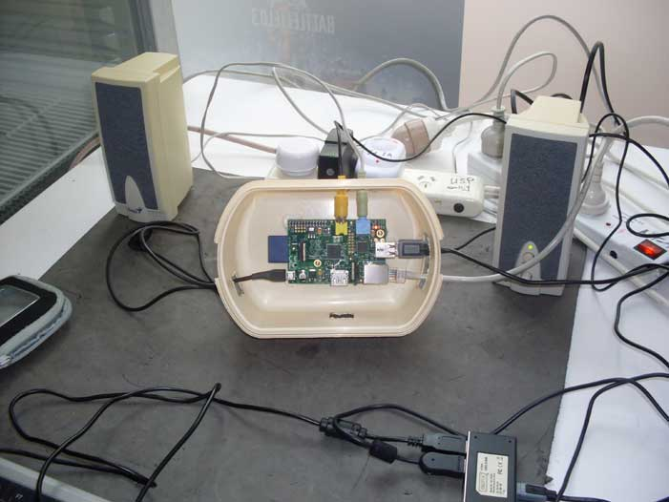

Home http://nofrillstech.net/

At last the tide of overdesigned, under-optimised, under-utilised, everyday computing is turning in favour of simpler and more affordable systems, and at the same time, potentially reducing the growth of computer waste. The advent of the Cloud, and online apps, make even more sense of system sbased on SBCs (single board computers), when the means to be in contact are more important than sheer computing power. The Pi will connect to an HDMI monitor, or, a simple TV with a yellow video port. VGA may yet make an appearance in the next model.

Look for Raspberry Pi Projects online, http://elinux.org/RPi_Projects, to see the interest shown in how the uses of the Pi can be expanded. http://element14.com/raspberrypi will supply the Pi, branches world-wide, http://raspberrypi.org/downloads will supply the Wheezy Raspian O/S, and an excellent info sheet, plus, there is also a handy Raspberry Pi Wiki , among many other sources of enthusiast information.

Running Open Source O/Ss on the Pi also means less complex and resource-hungry software, and, without the need for guardians, and the endless housekeeping that characterises Microsoft O/Ss, or, meeting the expense of owning Apple products. If all that is needed is to connect to browse the Internet, and to exchange emails, then the Pi does that easily, uses little power, and, does this without any problems, if connecting directly via a broadband outlet, or, via another computer.

Advantages over a smart phone are, that a real keyboard and monitor can be used, and, you can sit comfortably in front of the screen, though a smartphone will, of course, be potentially useful for tethering the Pi to the Internet. Space-saving and portablity are also useful factors.

Nofrillstech has tried the Wheezy Raspian O/S, installed on an SD card using Win32DiskImager, quite straightforward, and using a Class 4 SD card, which performs quite satisfactorily, tho no doubt higher class SDs will be correspondingly faster. There are advantages in loading your own cards, mainly less expense, and flexible choice of O/Ss available, but, if you make a fatal error tinkering with an O/S, it is so easy just to reload the card, and start again.

Wheezy Raspian, on first boot, will show a screen that gives Settings choices, recommend that, at first, just allow the O/S to occupy the entire card, also to boot to the Desktop when starting, and the Pi will soon be up and running. If you choose not to boot the the Desktop, then the username is 'pi', the password 'raspberry'. To return to the Settings screen, from the Desktop, 'sudo raspi-config', is the terminal command line, and then just 'Boot to Destop' to return.

There are over-clocking facilities available via the Settings screen, Nofrillstech has been satisfied with the modest 800 Mhz setting, anything higher at this stage is unnecessary, plus, whatever power-supply is to be used must be capable of meeting higher demands. For any overclocking, a small-self-adhesive cooling fin/heatsink plate should be used, and an additional system fan installed if the Pi is in a case.

A powered USB is also advisable for flexibility, and, to ease power requirements of the system. Speakers have their own power supply.n Nofrillstech also uses a small UPS in conjunction with the Pi, as for all our home systems, to ensure smooth and secure mains power delivery.

At this stage, for Nofrilstech, Wifi is, as yet, fiddly on the Pi, requiring a compatible USB facility, and software configuration, similarly, sound is as yet not utilised, nor other apps such as for Office-style tasks. Pi-related experiments continue..!

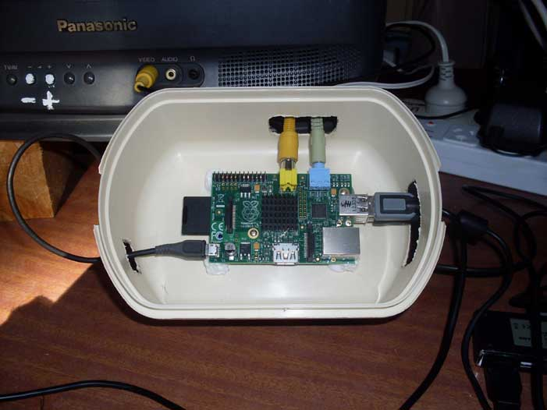

Pi with heatsink plate installed.
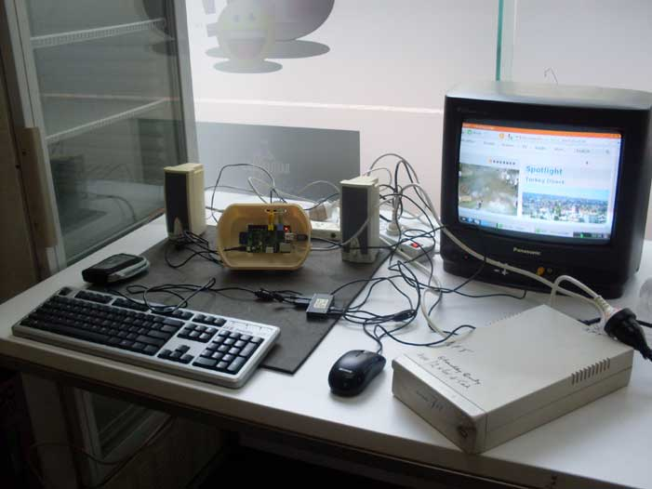

Pi Online for the first time, at the local Internet Cafe.

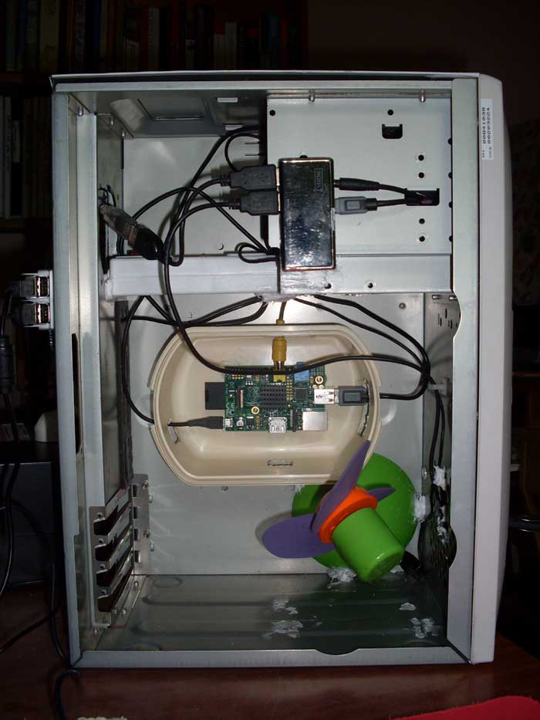
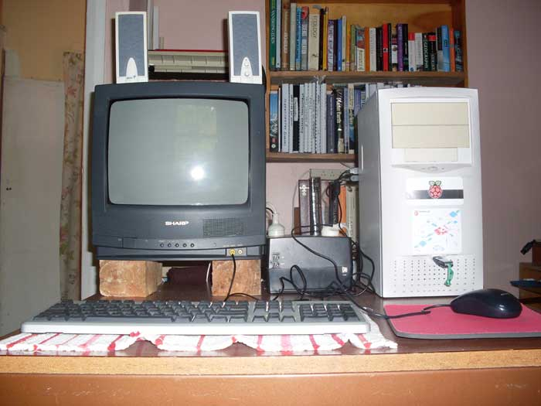

Home http://nofrillstech.net/

